**Welcome to Tree of Life Lutheran Church**

May 18, 2025 ~ Fifth Sunday of Easter

Leader in regular type, **congregation in bold type**

**↑** means stand as you are able

**Restrooms** are by the kitchen and by the Wiggle Room

**Wiggle Room** is available for anyone needing a brief break from worship, at the end of the piano wing of the sanctuary

**WiFi** is available: Look for TOL-GUEST; password is OdessaTOL1



**We Gather as God’s People**

**PRELUDE**

*You can use this time for quiet reflection, prayer and preparation for worship.*

**↑ CONFESSION AND FORGIVENESS**

Alleluia! Christ is risen!

**Christ is risen indeed! Alleluia!**

Trusting in the grace and life of the risen Christ, let us confess our sins in the presence of God and one-another. *Silence for reflection.*

Most merciful God: **We confess that we are captive to sin and cannot free ourselves. We have sinned against you in thought, word, and deed, by what we have done and by what we have left undone. We have not loved you with our whole heart; we have not loved our neighbors as ourselves. For the sake of your Son, Jesus Christ, have mercy on us. Forgive us, renew us, and lead us, so that we may delight in your will and walk in your ways, to the glory of your holy name. Amen.**

Baptized into Christ’s death and resurrection, we are forgiven and walk in newness of life. As a called and ordained minister of the church of Christ, and by his authority, I therefore declare to you the entire forgiveness of all your sins. Rejoice with glad hearts at the grace of God your Father, given through the risen +Christ,

in the unity of the Holy Spirit, now and forever. **Amen.**

**↑ HYMN “I Come With Joy” RED HYMNAL #482**

**↑ APOSTOLIC GREETING**

The grace of our Lord Jesus Christ, the love of God, and the communion of the Holy Spirit be with you all. **And also with you.**

**↑ HYMN OF PRAISE “This is the Feast”** *Composed by D.D. Dillard*

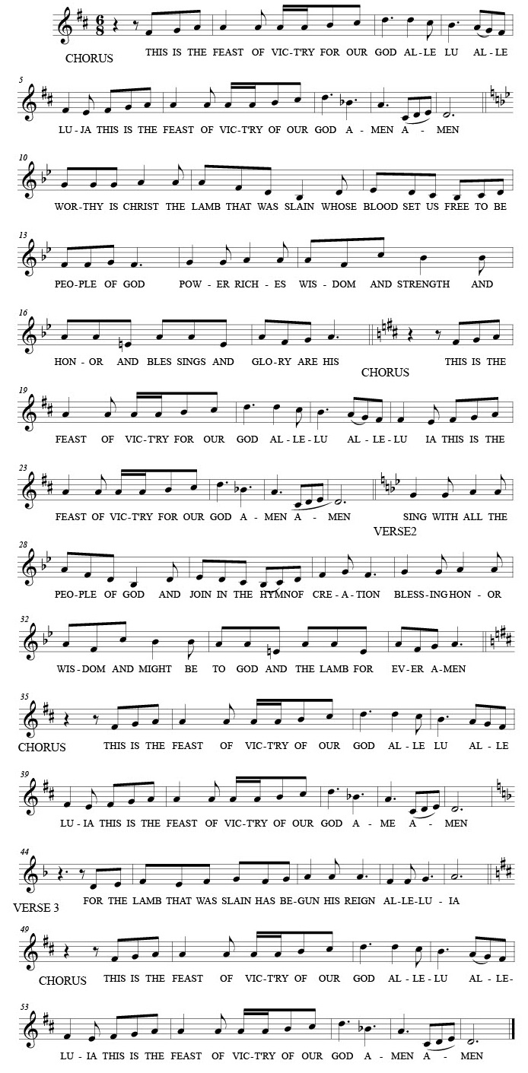



**↑ Prayer of the Day**

The Lord be with you. **And also with you.**

Let us pray: O Lord God, you teach us that without love, our actions gain nothing. Pour into our hearts your most excellent gift of love, that, made alive by your Spirit, we may know goodness and peace, through your Son, Jesus Christ, our Savior and Lord, who lives and reigns with you and the Holy Spirit, one God, now and forever. **Amen.**

**We Hear God’s Word**

**First Reading: Acts 11:1-18**

A reading from Acts:

1Now the apostles and the believers who were in Judea heard that the Gentiles had also accepted the word of God. 2So when Peter went up to Jerusalem, the circumcised believers criticized him, 3 saying, “Why did you go to uncircumcised men and eat with them?”

4Then Peter began to explain it to them, step by step, saying, 5“I was in the city of Joppa praying, and in a trance I saw a vision. There was something like a large sheet coming down from heaven, being lowered by its four corners; and it came close to me. 6As I looked at it closely I saw four-footed animals, beasts of prey, reptiles, and birds of the air. 7I also heard a voice saying to me, ‘Get up, Peter; kill and eat.’ 8But I replied, ‘By no means, Lord; for nothing profane or unclean has ever entered my mouth.’ 9But a second time the voice answered from heaven, ‘What God has made clean, you must not call profane.’ 10This happened three times; then everything was pulled up again to heaven.

11“At that very moment three men, sent to me from Caesarea, arrived at the house where we were. 12The Spirit told me to go with them and not to make a distinction between them and us. These six brothers also accompanied me, and we entered the man’s house. 13He told us how he had seen the angel standing in his house and saying, ‘Send to Joppa and bring Simon, who is called Peter; 14 he will give you a message by which you and your entire household will be saved.’ 15And as I began to speak, the Holy Spirit fell upon them just as it had upon us at the beginning. 16And I remembered the word of the Lord, how he had said, ‘John baptized with water, but you will be baptized with the Holy Spirit.’ 17 If then God gave them the same gift that he gave us when we believed in the Lord Jesus Christ, who was I that I could hinder God?”

18 When they heard this, they were silenced. And they praised God, saying, “Then God has given even to the Gentiles the repentance that leads to life.”

The word of the Lord. **Thanks be to God.**

**Psalm: Psalm 148**

1 Hallelujah! Praise the Lord from the heavens; praise God in the heights.  
 2 **Praise the Lord, all you angels;** **sing praise, all you hosts of heaven.**  
 3 Praise the Lord, sun and moon; sing praise, all you shining stars.  
 4 **Praise the Lord, heaven of heavens,** **and you waters above the heavens.**  
 5 Let them praise the name of the Lord, who commanded, and they were created,  
 6 **who made them stand fast forever and ever,**  
  **giving them a law that shall not pass away.**  
 7 Praise the Lord from the earth, you sea monsters and all deeps;  
 8 **fire and hail, snow and fog,** **tempestuous wind, doing God’s will;**  
 9 mountains and all hills, fruit trees and all cedars;  
 10 **wild beasts and all cattle,** **creeping things and flying birds;**  
 11 sovereigns of the earth and all peoples, princes and all rulers of the world;  
 12 **young men and maidens,** **old and young together.**  
 13 Let them praise the name of the Lord,  
  whose name only is exalted, whose splendor is over earth and heaven.  
 14 **The Lord has raised up strength for the people and praise for all faithful**

**servants, the children of Israel, a people who are near the Lord. Hallelujah!**

**Second Reading: Revelation 21:1-6**

A reading from Revelation:

1I saw a new heaven and a new earth; for the first heaven and the first earth had passed away, and the sea was no more. 2And I saw the holy city, the new Jerusalem, coming down out of heaven from God, prepared as a bride adorned for her husband. 3And I heard a loud voice from the throne saying, “See, the home of God is among mortals. He will dwell with them; they will be his peoples, and God himself will be with them; 4he will wipe every tear from their eyes. Death will be no more; mourning and crying and pain will be no more, for the first things have passed away.”

5And the one who was seated on the throne said, “See, I am making all things new.” Also he said, “Write this, for these words are trustworthy and true.” 6Then he said to me, “It is done! I am the Alpha and the Omega, the beginning and the end. To the thirsty I will give water as a gift from the spring of the water of life.”

The word of the Lord. **Thanks be to God.**

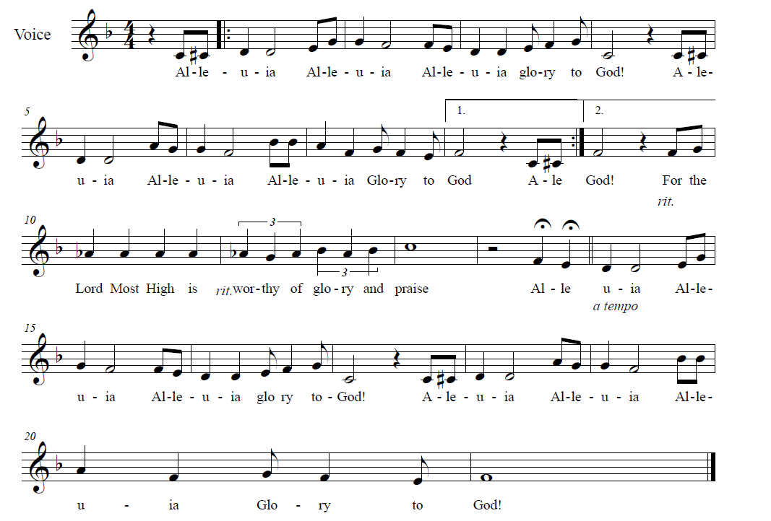**↑ GOSPEL ACCLAMATION** *Composed by D.D. Dillard*

**↑** **Gospel: John 13:31-35**

The holy gospel according to John. **Glory to you, O Lord.**

31 When he had gone out, Jesus said, “Now the Son of Man has been glorified, and God has been glorified in him. 32 If God has been glorified in him, God will also glorify him in himself and will glorify him at once. 33 Little children, I am with you only a little longer. You will look for me; and as I said to the Jews so now I say to you, ‘Where I am going, you cannot come.’ 34 I give you a new commandment, that you love one another. Just as I have loved you, you also should love one another. 35 By this everyone will know that you are my disciples, if you have love for one another.”

The gospel of the Lord.

**Praise to you, O Christ.**

**CHILDREN’S SERMON**

**Sermon**

**↑ HYMN “Great Is The Lord” BLACK BINDER #24**

**↑ PRayers of Intercession**

Rejoicing in the risen Lord, let us pray for the Church, the world, and all in need:

We praise you, Lord, with all the angels. Send your Spirit upon your Church in all times and places. Make us steadfast in our proclamation of your grace for all people without exception, and grant that your Word may bring all people life and salvation. God of grace… **Hear our prayer.**

We praise you, Lord, with the creatures of the earth. Awaken joy in the beauty and abundance of your creation. Show us the wonder of your presence in distant stars and nearby forests, wild beasts and flying birds, tiny flowers and tall trees. Make us good stewards of what you have entrusted to us. God of grace… **Hear our prayer.**

We praise you, Lord, with princes and rulers of the world. Inspire all leaders to seek freedom, justice and peace. Lead those in authority to seek unity rather than division. Overcome the prejudice, discord and enmity that keep us from fully loving one-another. God of grace… **Hear our prayer.**

We praise you, Lord, with all your people. Be with those who face sorrow, grief, tragedy, trauma, illness and pain. Wipe away the tears from all faces, as we await the day when crying and pain will be no more. We especially pray for Amanda, Annalise, Bill, Bob, Cecelia, Chris, Danielle, Edwin, Elizabeth, Erica, Gail, Kimberly, Noretta, Patrick, Paul, Sarah, William, Winnie and those we name with our lips or in our hearts… *(Time for personal petitions)* God of grace… **Hear our prayer.**

We praise you, Lord, and exalt your holy name. Lead all of us at Tree of Life love one-another as your Son loves us, that your name may be glorified through our witness and through our work. Bless our bishops, Elizabeth and William; our pastor, Robbie; Community Lutheran Church and its pastor, Karis; and Grace of God Community Church. God of grace… **Hear our prayer.**

We praise you, Lord, for all time. Accept our thanksgiving for those whose earthly journey has ended and who now praise you in perfect joy. Sustain our hope in the sure promise of that day when you will dwell among us forever. God of grace…

**Hear our prayer.**

We commend these and all our prayers to you, O God, trusting that you are always with us; in the name of Jesus Christ, our risen Savior and Lord. **Amen.**

**↑ Peace**

The peace of Christ be with you always***.* And also with you.**

**We Share God’s Holy Meal**

**↑ OFFERTORY “We Believe” Charles W. Platt**

**↑ Offering Prayer**

Let us pray together: **Risen Lord, you have gathered us around your table of grace along with these gifts we bring. Be with us in this meal, and make us your risen body in the world. Amen.**

**↑ great thanksgiving**

*The thanksgiving continues with the preface for the day. The congregation responds:*

**↑ SANCTUS** *Composed by D.D. Dillard*

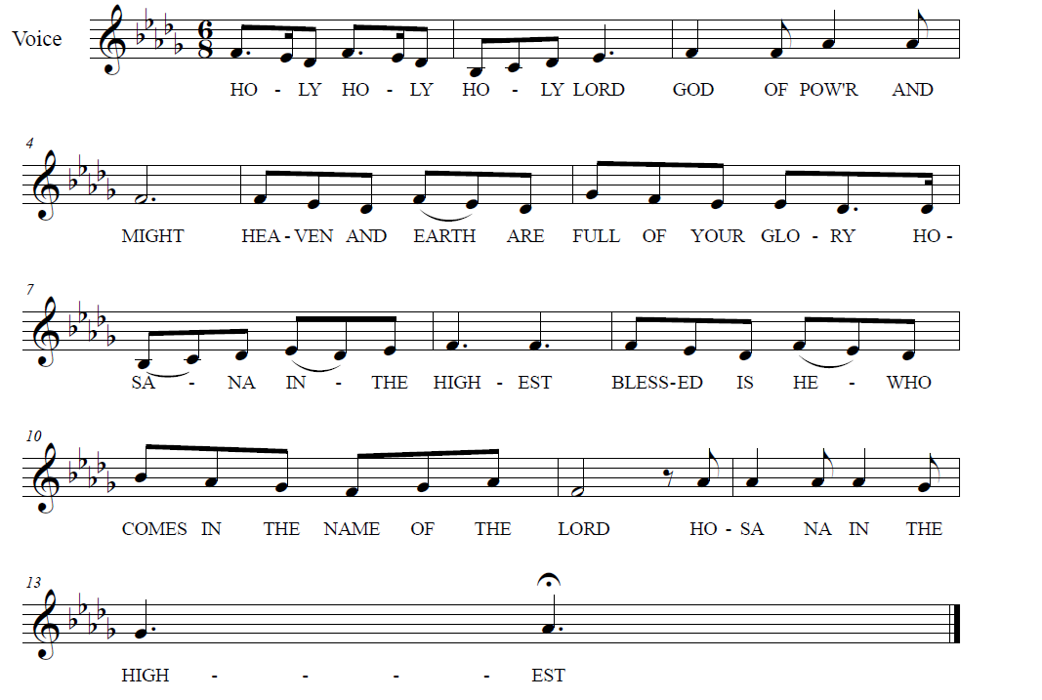

**

**↑ EUCHARISTIC PRAYER & WORDS OF INSTITUTION**

In the night in which he was betrayed, our Lord Jesus took bread, and gave thanks; broke it, and gave it to his disciples, saying: Take and eat; this is my body, given for you. Do this for the remembrance of me.

Again, after supper, he took the cup, gave thanks, and gave it for all to drink, saying: This cup is the new covenant in my blood, shed for you and for all people for the forgiveness of sin. Do this for the remembrance of me.

**↑ LORD’S PRAYER**

**Our Father, who art in heaven, hallowed be thy name,**

**thy kingdom come, thy will be done, on earth as it is in heaven.**

**Give us this day our daily bread.**

**And forgive us our trespasses, as we forgive those who trespass against us.**

**And lead us not into temptation, but deliver us from evil.**

**For thine is the kingdom, and the power, and the glory, forever and ever. Amen.**

**↑ INVITATION TO COMMUNION**

Alleluia, Christ our salvation is given for us!

**Therefore let us keep the feast! Alleluia!**

*All baptized Christians are welcome to commune. Wine and white grape juice are in the individual cups. Gluten-free wafers are available upon request.*

**COMMUNION** *Composed by D.D. Dillard*

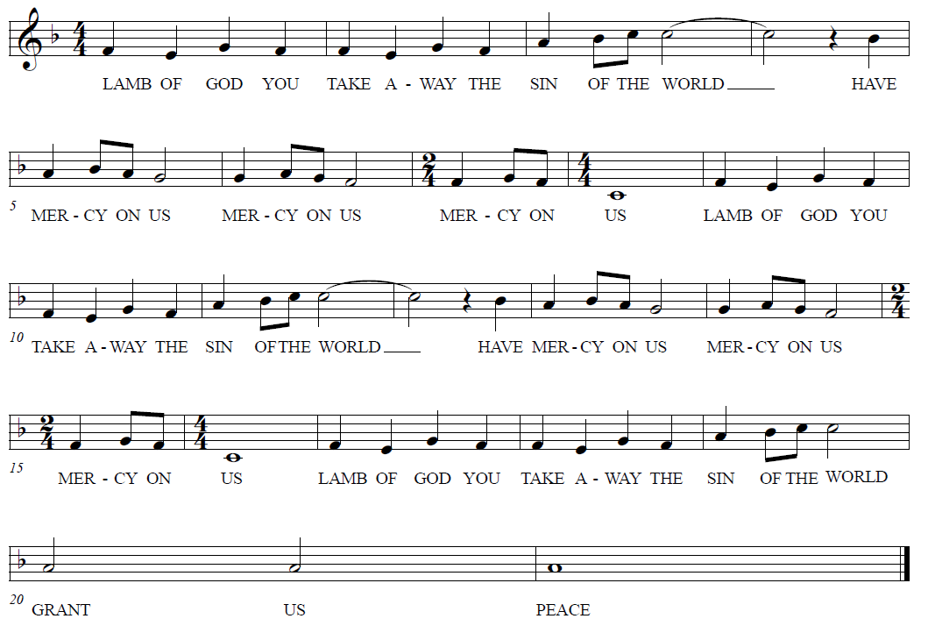

**HYMNS “Bread Of Life Our Host Our Meal” RED HYMNAL #464**

**“We Come To The Hungry Feast” RED HYMNAL #479**

**Prayer after Communion**

Let us pray together: **Living Lord Jesus, in this feast you have made yourself known to us. Send us now to tell of your wonders, sing of your glory, and proclaim your risen life to a wounded and weary world. Amen.**

**God Sends Us in Mission**

**Announcements**

**↑ Benediction**

The Lord bless you and keep you. The Lord’s face shine upon you with be gracious to you. The Lord look upon you with favor and ☩ give you peace. **Amen.**

**↑ HYMN** **“My Life Flows On In Endless Song” RED HYMNAL #763**

**↑ MISSION STATEMENT**

What is our Mission? **To be faithful children of God, called by grace through Christ, and sharing this gift with Middletown, Odessa, Townsend and the World.**

**↑ Dismissal**

Go in peace! Share the Good News! Alleluia!

**Thanks be to God! Alleluia!**

**POSTLUDE**

*You may listen to the music or depart to do God’s work.*

*Please join us for refreshments in the fellowship room after the service.*



From Sundays and Seasons.com. Copyright 2025 Augsburg Fortress. All rights reserved.

Reprinted by permission under Augsburg Fortress Liturgies Annual License #28947.New Revised Standard Version Bible, copyright 1989, Division of Christian Education of the National Council of the Churches of Christ in the United States of America. Used by permission. All rights reserved.