**Welcome to Tree of Life Lutheran Church**

May 25, 2025 ~ Sixth Sunday of Easter

Leader in regular type, **congregation in bold type**

**↑** means stand as you are able

**Restrooms** are by the kitchen and by the Wiggle Room

**Wiggle Room** is available for anyone needing a brief break from worship, at the end of the piano wing of the sanctuary

**WiFi** is available: Look for TOL-GUEST; password is OdessaTOL1



**We Gather as God’s People**

**PRELUDE**

*You can use this time for quiet reflection, prayer and preparation for worship.*

**↑ CONFESSION AND FORGIVENESS**

Alleluia! Christ is risen!

**Christ is risen indeed! Alleluia!**

Trusting in the grace and life of the risen Christ, let us confess our sins in the presence of God and one-another. *Silence for reflection.*

Most merciful God: **We confess that we are captive to sin and cannot free ourselves. We have sinned against you in thought, word, and deed, by what we have done and by what we have left undone. We have not loved you with our whole heart; we have not loved our neighbors as ourselves. For the sake of your Son, Jesus Christ, have mercy on us. Forgive us, renew us, and lead us, so that we may delight in your will and walk in your ways, to the glory of your holy name. Amen.**

Baptized into Christ’s death and resurrection, we are forgiven and walk in newness of life. As a called and ordained minister of the church of Christ, and by his authority, I therefore declare to you the entire forgiveness of all your sins. Rejoice with glad hearts at the grace of God your Father, given through the risen +Christ,

in the unity of the Holy Spirit, now and forever. **Amen.**

**↑ HYMN “Immortal Invisible God Only Wise” RED HYMNAL #834**

**↑ APOSTOLIC GREETING**

The grace of our Lord Jesus Christ, the love of God, and the communion of the Holy Spirit be with you all. **And also with you.**

**↑ HYMN OF PRAISE “This is the Feast”** *Composed by D.D. Dillard*

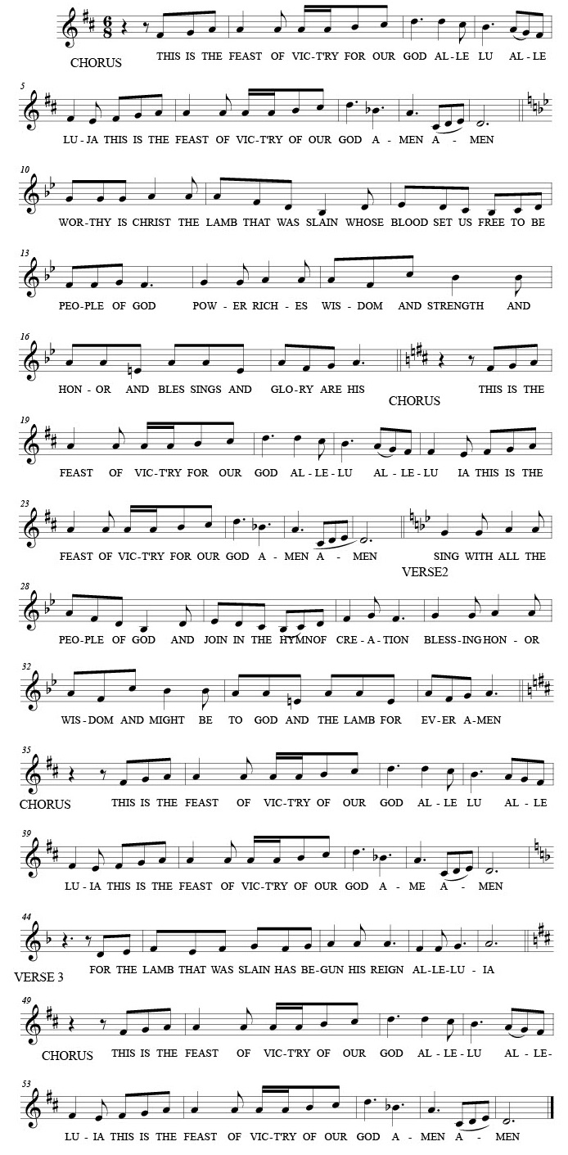



**↑ Prayer of the Day**

The Lord be with you. **And also with you.**

Let us pray: Bountiful God, you gather your people into your realm, and you promise us food from your tree of life. Nourish us with your word, that empowered by your Spirit we may love one another and the world you have made, through Jesus Christ, our Savior and Lord, who lives and reigns with you and the Holy Spirit, one God, now and forever. **Amen.**

**We Hear God’s Word**

**First Reading: Acts 16:9-15**

A reading from Acts:

9 During the night Paul had a vision: There stood a man of Macedonia pleading with him and saying, “Come over to Macedonia and help us.” 10 When he had seen the vision, we immediately tried to cross over to Macedonia, being convinced that God had called us to proclaim the good news to them.  
   11 We set sail from Troas and took a straight course to Samothrace, the following day to Neapolis, 12 and from there to Philippi, which is a leading city of the district of Macedonia and a Roman colony. We remained in this city for some days. 13 On the sabbath day we went outside the gate by the river, where we supposed there was a place of prayer; and we sat down and spoke to the women who had gathered there. 14 A certain woman named Lydia, a worshiper of God, was listening to us; she was from the city of Thyatira and a dealer in purple cloth. The Lord opened her heart to listen eagerly to what was said by Paul. 15 When she and her household were baptized, she urged us, saying, “If you have judged me to be faithful to the Lord, come and stay at my home.” And she prevailed upon us.

The word of the Lord. **Thanks be to God.**

**Psalm: Psalm 67**

1 May God be merciful to us and bless us; may the light of God’s face shine upon us.  
2 **Let your way be known upon earth, your saving health among all nations.**

**3 Let the peoples praise you, O God; let all the peoples praise you.** 4 Let the nations be glad and sing for joy,  
  for you judge the peoples with equity and guide all the nations on earth.   
 **5 Let the peoples praise you, O God; let all the peoples praise you.** 6 The earth has brought forth its increase; God, our own God, has blessed us.  
**7 May God give us blessing, and may all the ends of the earth stand in awe.**

**Second Reading: Revelation 21:10, 22 – 22:5**

A reading from Revelation:

10 And in the spirit [one of the angels] carried me away to a great, high mountain and showed me the holy city Jerusalem coming down out of heaven from God. 22 I saw no temple in the city, for its temple is the Lord God the Almighty and the Lamb. 23 And the city has no need of sun or moon to shine on it, for the glory of God is its light, and its lamp is the Lamb. 24 The nations will walk by its light, and the kings of the earth will bring their glory into it. 25Its gates will never be shut by day – and there will be no night there. 26 People will bring into it the glory and the honor of the nations. 27 But nothing unclean will enter it, nor anyone who practices abomination or falsehood, but only those who are written in the Lamb’s book of life.

22:1Then the angel showed me the river of the water of life, bright as crystal, flowing from the throne of God and of the Lamb 2through the middle of the street of the city. On either side of the river is the tree of life with its twelve kinds of fruit, producing its fruit each month; and the leaves of the tree are for the healing of the nations. 3Nothing accursed will be found there any more. But the throne of God and of the Lamb will be in it, and his servants will worship him; 4they will see his face, and his name will be on their foreheads. 5And there will be no more night; they need no light of lamp or sun, for the Lord God will be their light, and they will reign forever and ever.

The word of the Lord.

**Thanks be to God.**

**↑ GOSPEL ACCLAMATION** *Composed by D.D. Dillard*

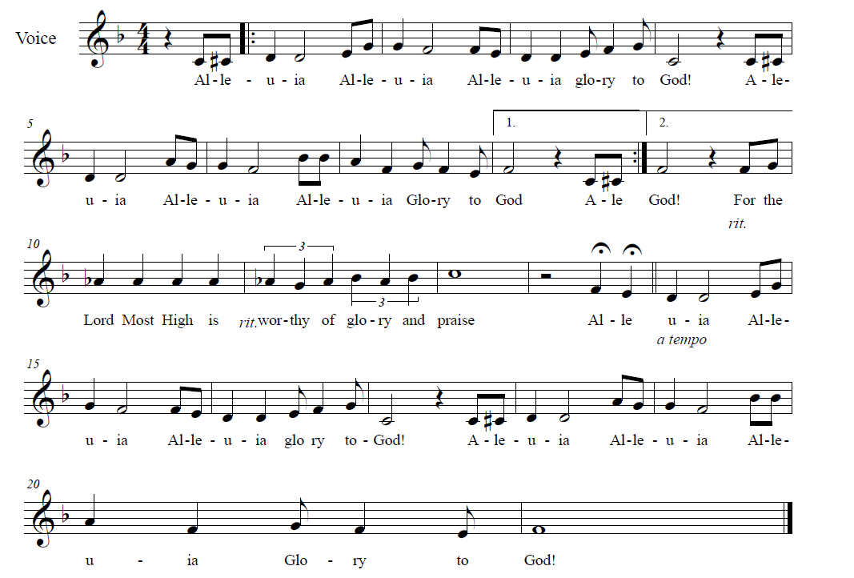



**↑** **Gospel: John 14:18-29**

The holy gospel according to John.

**Glory to you, O Lord.**

**[Jesus said,]** 18“I will not leave you orphaned; I am coming to you. 19In a little while the world will no longer see me, but you will see me; because I live, you also will live. 20On that day you will know that I am in my Father, and you in me, and I in you. 21They who have my commandments and keep them are those who love me; and those who love me will be loved by my Father, and I will love them and reveal myself to them."

22Judas (not Iscariot) said to him, "Lord, how is it that you will reveal yourself to us, and not to the world?"

23Jesus answered him, "Those who love me will keep my word, and my Father will love them, and we will come to them and make our home with them. 24Whoever does not love me does not keep my words; and the word that you hear is not mine, but is from the Father who sent me.

25 “I have said these things to you while I am still with you. 26 But the Advocate, the Holy Spirit, whom the Father will send in my name, will teach you everything, and remind you of all that I have said to you. 27 Peace I leave with you; my peace I give to you. I do not give to you as the world gives. Do not let your hearts be troubled, and do not let them be afraid. 28 You heard me say to you, ‘I am going away, and I am coming to you.’ If you loved me, you would rejoice that I am going to the Father, because the Father is greater than I. 29 And now I have told you this before it occurs, so that when it does occur, you may believe.”

The gospel of the Lord.

**Praise to you, O Christ.**

**CHILDREN’S SERMON**

**Sermon**

**↑ HYMN “O Spirit Of Life” RED HYMNAL #405**

**↑ PRayers of Intercession**

Rejoicing in the risen Lord, let us pray for the Church, the world, and all in need:

Almighty and ever-loving God, the light of your face shines upon us. Fill your Church in all times and places with your light, and inspire us to proclaim the Good News of Jesus to new populations and new generations. God of grace… **Hear our prayer.**

Your earth brings forth its increase, an abundance of blessing for all your creatures. Bless our rivers and trees, our fields and forests, and all that lives in them. Help those affected by recent tornadoes and severe storms, and keep us safe from natural disaster. God of grace… **Hear our prayer.**

You judge the people with equity and guide the nations of the earth. Bless our nation and all who lead it. On this Memorial Day weekend, accept our thanksgiving for those in our military throughout history who have sacrificed their lives for their fellow citizens and for us who came after. Comfort all who mourn, and be present with all who are serving in the military today. God of grace… **Hear our prayer.**

You calm our troubled hearts with true peace. Sustain all who are poor, lonely, afraid or in any need of body, mind or spirit. We especially pray for Amanda, Annalise, Bill, Bob, Chris, Dan, Danielle, Dot, Elizabeth, Erica, Kimberly, Patrick, Paul, Sarah, William, Winnie and those we name with our lips or in our hearts… *(Time for personal petitions)* God of grace… **Hear our prayer.**

You promise the tree of life to all the faithful. Inspire this congregation of Tree of Life to live up to our namesake and be an earthly foretaste of your eternal tree of life. Help us bear the fruit of love, bring forth leaves of healing, and root ourselves in your Son. Bless our bishops, Elizabeth and William; our pastor, Robbie; Lutheran Church of the Good Shepherd and its interim pastor, Kibreab; and Lutheran housing projects throughout Delaware. God of grace… **Hear our prayer.**

You promise that day when you will make your home among us. Receive our thanks for all the saints who now rest in your perfect peace. Be with all who grieve, and sustain us in hope until our eternal reunion. God of grace… **Hear our prayer.**

We commend these and all our prayers to you, O God, trusting that you are always with us; in the name of Jesus Christ, our risen Savior and Lord. **Amen.**

**↑ Peace**

The peace of Christ be with you always***.* And also with you.**

**We Share God’s Holy Meal**

**OFFERING “When Memory Fades” RED HYMNAL #792**

*Tree of Life Choir*

**↑ OFFERTORY “We Believe” Charles W. Platt**

**↑ Offering Prayer**

Let us pray together: **Risen Lord, you have gathered us around your table of grace along with these gifts we bring. Be with us in this meal, and make us your risen body in the world. Amen.**

**↑ great thanksgiving**

*The thanksgiving continues with the preface for the day. The congregation responds:*

**↑ SANCTUS** *Composed by D.D. Dillard*

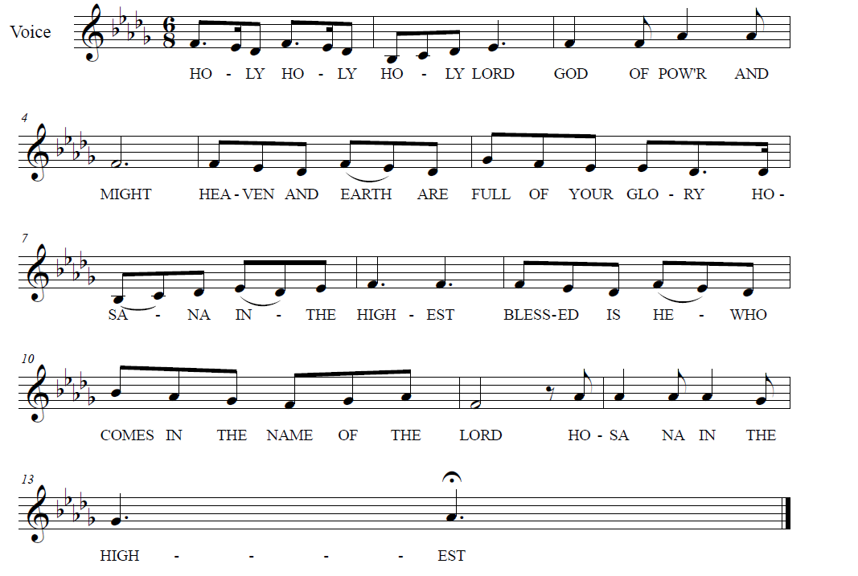

**

**↑ EUCHARISTIC PRAYER & WORDS OF INSTITUTION**

In the night in which he was betrayed, our Lord Jesus took bread, and gave thanks; broke it, and gave it to his disciples, saying: Take and eat; this is my body, given for you. Do this for the remembrance of me.

Again, after supper, he took the cup, gave thanks, and gave it for all to drink, saying: This cup is the new covenant in my blood, shed for you and for all people for the forgiveness of sin. Do this for the remembrance of me.

**↑ LORD’S PRAYER**

**Our Father, who art in heaven, hallowed be thy name,**

**thy kingdom come, thy will be done, on earth as it is in heaven.**

**Give us this day our daily bread.**

**And forgive us our trespasses, as we forgive those who trespass against us.**

**And lead us not into temptation, but deliver us from evil.**

**For thine is the kingdom, and the power, and the glory, forever and ever. Amen.**

**↑ INVITATION TO COMMUNION**

Alleluia, Christ our salvation is given for us!

**Therefore let us keep the feast! Alleluia!**

*All baptized Christians are welcome to commune. Wine and white grape juice are in the individual cups. Gluten-free wafers are available upon request.*

**COMMUNION** *Composed by D.D. Dillard*

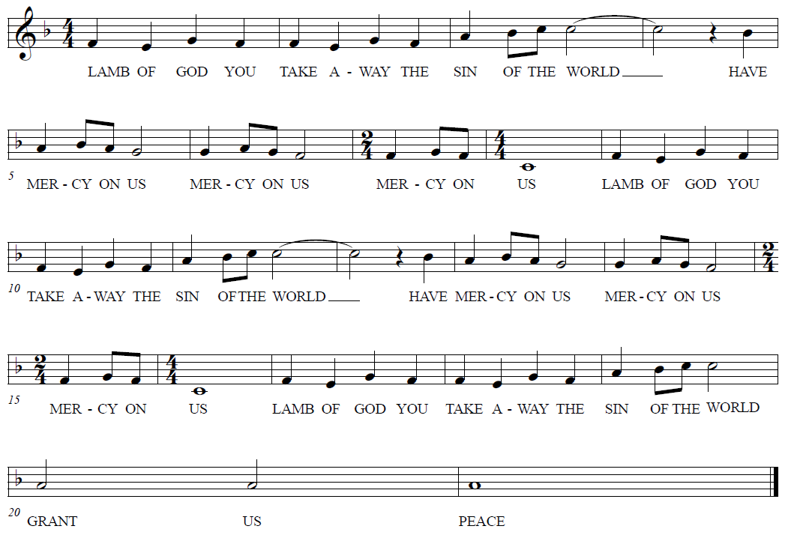

**HYMNS “Bread Of Life Our Host Our Meal” RED HYMNAL #464**

**“We Come To The Hungry Feast” RED HYMNAL #479**

**Prayer after Communion**

Let us pray together: **Living Lord Jesus, in this feast you have made yourself known to us. Send us now to tell of your wonders, sing of your glory, and proclaim your risen life to a wounded and weary world. Amen.**

**God Sends Us in Mission**

**Announcements**

**↑ Benediction**

The Lord bless you and keep you. The Lord’s face shine upon you with be gracious to you. The Lord look upon you with favor and ☩ give you peace. **Amen.**

**↑ HYMN** **“We Are Marching In The Light Of God” RED HYMNAL #866**

**↑ MISSION STATEMENT**

What is our Mission? **To be faithful children of God, called by grace through Christ, and sharing this gift with Middletown, Odessa, Townsend and the World.**

**↑ Dismissal**

Go in peace! Share the Good News! Alleluia!

**Thanks be to God! Alleluia!**

**POSTLUDE**

*You may listen to the music or depart to do God’s work.*

*Please join us for refreshments in the fellowship room after the service.*



From Sundays and Seasons.com. Copyright 2025 Augsburg Fortress. All rights reserved.

Reprinted by permission under Augsburg Fortress Liturgies Annual License #28947.New Revised Standard Version Bible, copyright 1989, Division of Christian Education of the National Council of the Churches of Christ in the United States of America. Used by permission. All rights reserved.